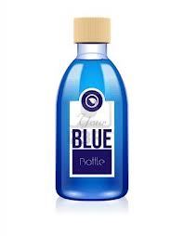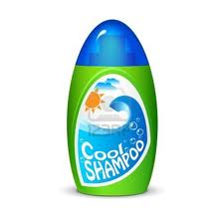

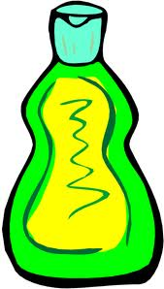 Year 9 Science Chemistry

Shampoo Practical - Experimental Design

**Name: ________________________**

**Mark _____/30**

**Task:** Design and conduct an experiment to determine:

(I) if the pH of various types of hair shampoo is different, and

1. if there is any relationship between their pH and the type of hair for which they are intended.

**Instructions:**

The Shampoo Practical is divided into three sections, the first two sections will be completed in groups. Each student will produce their own report and receive an individual mark.

## A. PLANNING

Plan your investigation.

*Check with your teacher when you have completed the plan.*

## B. EXPERIMENT

Record all results in an appropriate table.

Construct a suitable graph of the results.

Discussion - Consider how well your experimental method worked

## C. CONCLUSION

Write a conclusion for your experiment.

What Relationship do you notice between the pH of the shampoo and the type of hair it was designed for?

|  |  |  |  |
| --- | --- | --- | --- |
| **Part** | **Details** | **Available**  **mark** | **Your**  **mark** |
| Title |  | 1 |  |
| Aim |  | 1 |  |
| Hypothesis | Correctly worded | 2 |  |
| Independent Variable | The factor you changed | 1 |  |
| Dependent Variable | What you measured? | 1 |  |
| Controlled Variables | The factors you controlled | 2 |  |
| Materials | Complete  Listed | 2 |  |
| Method | Step by step with numbers  Written in past tense  Complete  Labelled Diagrams | 1  1  1  2 |  |
| Results | Table - neat & clear with units  Graph – Include  Title, Label Axis, Measurements, Regular scale, Neat & Accurate, Use Pencil | 2  5 |  |
| Discussion | How could fairness/ accuracy improve  Errors, Effects of errors, Solutions | 3 |  |
| Conclusion | What did the results show  Use figures from your results  Does this support your hypothesis  Scientific reasons | 1  1  3 |  |
| **Total mark** | | **30** |  |

**TITLE: ____________________________________________________** (1 mark)

AIM: **_____________________________________________________** (1 mark)

1. What is the independent variable? (the factor you changed) (1 mark)

2. What is the dependent variable? (the factor you measure) (1 mark)

3. List the controlled variables? (the factors you keep the same) (2 marks)

4. Write a hypothesis (2 marks)

5. List the apparatus/equipment you need? (2 marks)

6. Method : Write, in point form, what you plan to do in your experiment. (3 marks)

Labelled Diagrams of your equipment (2 marks)

##### **Now check with your teacher**

### B. EXPERIMENT

1. Record your results in an **appropriate** table into this space.

(neat and clear – include units) (2 marks)

2. What type of graph will best suit your results?

_________________________________________________________

_________________________________________________________

3. Draw the graph. (5 marks)

Do this onto graph paper

(Remember: Title, Label Axis, Measurements

Regular Scale, Neat Accurate graphing, Use Pencil)

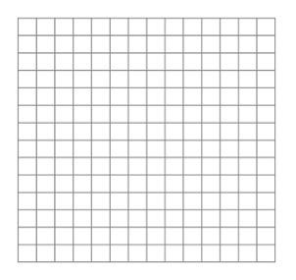

4. How could the fairness /accuracy of the shampoo experiment be improved? (3 marks)

Errors

Effect of Errors

Ways to improve experiment

#### C. CONCLUSION

1. What did the results show? (1mark)

Use figures from your results

Does this support your hypothesis? (1mark)

**Relationship between pH and Shampoo Hair Type**

1. What relationship did you notice between the pH of the shampoo and

the type of hair it was designed for? (3 marks)